**Android Developer Notes**

**Foreground VS Background Services**

👉 Use **Foreground Service** when:

* The task is long-running **and** user must be aware of it.
* Eg. music apps, navigation apps, fitness apps.

👉 Use **Background Service** when:

* The task is **short-lived** and user doesn’t need to know.
* On modern Android → better to use **WorkManager** or **JobScheduler**.

👉 Golden Rule:

* **User-aware ongoing work** → Foreground Service.
* **Silent, scheduled, deferrable work** → WorkManager / JobScheduler.
* **Quick async work (while app active)** → Background Service.

• Before Android 8.0 (Oreo), you could run long-lived background services easily.

• After Oreo → **restrictions**:

* Apps in the background cannot freely start background services.
* If they try, the system throws an **IllegalStateException**.

**1. Foreground Service**

A **Foreground Service** performs tasks that the **user is actively aware of** and usually interacts with indirectly.

* Example: Playing music, recording location during navigation, fitness tracking.

**Key points:**

* Must display a **persistent notification** (cannot be swiped away).
* Runs even if the app is killed (until stopped explicitly).
* Android considers it **less likely to be killed** due to memory pressure.
* Requires **startForeground()** within 5 seconds of starting the service.
* Needs **FOREGROUND_SERVICE permission** in manifest.

**When to use:**

* Tasks that user should always be aware of.
* Media playback, tracking location, uploading large files, health monitoring

**🔹 2. Background Service**

A **Background Service** runs in the background without notifying the user.

* Example: Syncing data, fetching updates from server.

**Key points:**

* Runs silently without a persistent notification.
* Since **Android 8.0 (Oreo)** → background services are restricted:
  + Can’t keep running indefinitely.
  + If you need long-running background work → use **WorkManager** or **JobScheduler**.
* If the app goes to background, background service might be killed by the system.

**When to use:**

* Quick tasks (under a few minutes).
* Periodic jobs → best done with **WorkManager**.

|  |  |  |
| --- | --- | --- |
| Feature | Foreground Service | Background Service |
| User Awareness | Visible (via notification) | Hidden |
| Survival | Less likely to be killed | Can be killed anytime |
| Use Case | Music, location, file upload | Sync, short tasks |
| Battery impact | Higher (always running) | Lower |
| Restrictions (Android O+) | Allowed with notification | Severely restricted |
| API / Alternatives | startForegroundService() | WorkManager / JobScheduler |

Instead of a raw BackgroundService, use **WorkManager** because:

* It is **backward compatible**.
* It automatically decides how to run:
  + Uses **JobScheduler** (API 23+)
  + Uses **AlarmManager + BroadcastReceiver** on lower APIs
* Ensures the task will run, even after app restart.
* Perfect for tasks like syncing data, uploading logs, refreshing cache.

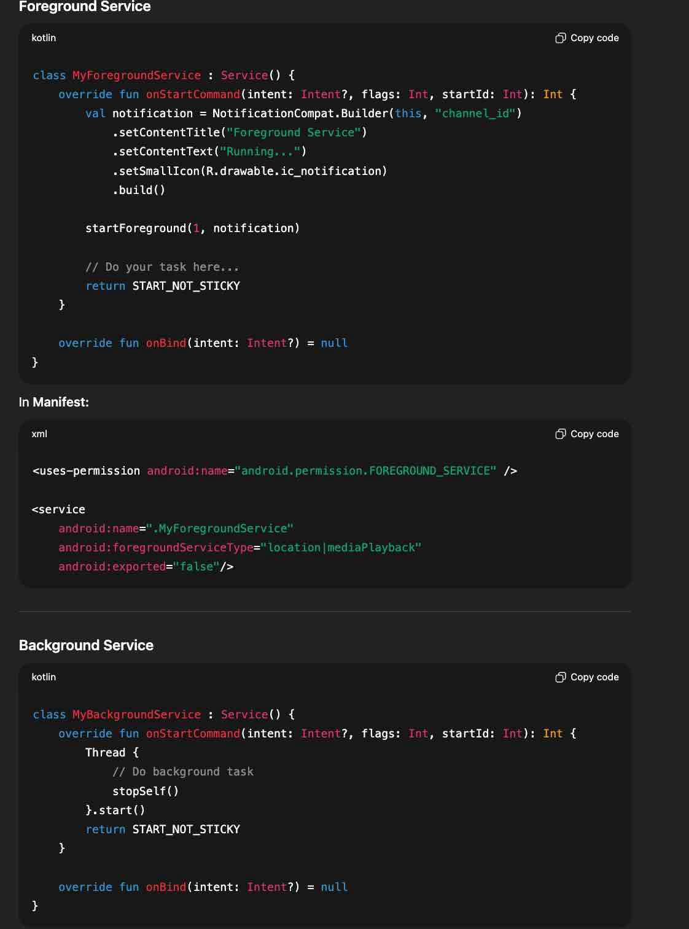

**Workmanager**

WorkManager is an **Android Jetpack library** used for scheduling and running **deferrable, asynchronous background tasks** that:

* Need **guaranteed execution** (even if the app is killed or the device restarts).
* Are **persistent** across app restarts.
* Respect **battery optimization, Doze mode, and API level restrictions**.

It’s the **recommended solution** for most background work that doesn’t need immediate execution (like Foreground Services).

**When to Use WorkManager**

You should use WorkManager for tasks such as:

* Uploading logs or analytics.
* Syncing data periodically.
* Backing up files to cloud storage.
* Sending deferred notifications.

If you need:

* **Immediate task execution** → use **Foreground Service**.
* **Exact timing (like alarms)** → use **AlarmManager**.
* **Long-running background work** → use **WorkManager with Foreground Service**.

**Key Features**

* **Guaranteed execution** → task will run even if app/process is killed.
* **Chaining tasks** → run tasks sequentially or in parallel.
* **Constraints** → run tasks only under conditions (e.g., device charging, Wi-Fi connected).
* **Backoff policy** → retries with exponential or linear delays.
* **Periodic tasks** → repeat work on schedule.
* **🚦 WorkManager vs Other Options**

| **API** | **Best For** |
| --- | --- |
| **WorkManager** | Guaranteed background work, deferrable, persistent |
| **Foreground Service** | Immediate, user-visible, long tasks (music, navigation) |
| **AlarmManager** | Exact alarms at specific times |
| **JobScheduler** | System-managed jobs (API 21+), WorkManager actually uses this under the hood |

**WorkManager** → Jetpack library that provides **backward-compatibility**:

* + On API 23+ → internally uses **JobScheduler**.
  + On lower APIs → falls back to **AlarmManager + BroadcastReceiver**.

**Foreground Service + Work Manager**

You’re uploading a large file. User must see **upload progress** → Foreground Service (with notification). Upload must **continue in background**, even if the app is closed → WorkManager.

**Architecture**

**WorkManager (Worker)** → handles the actual long-running upload. **Foreground Service** → shows progress notification (binds to the worker).

**🔹 How This Solves It**

**WorkManager** → ensures upload runs to completion, even if the app is killed.**Foreground Service** → ensures user is aware of the ongoing upload and sees progress.

* + Service = UI awareness.
  + WorkManager = reliable executionn

✅ **Interview Answer**:  
“In real-world apps like file uploads, we often combine a Foreground Service and WorkManager. The Foreground Service displays a persistent notification so the user knows an upload is happening, while WorkManager actually performs the upload reliably in the background. This way, if the app is killed, the task continues, and the user is always aware of progress.”

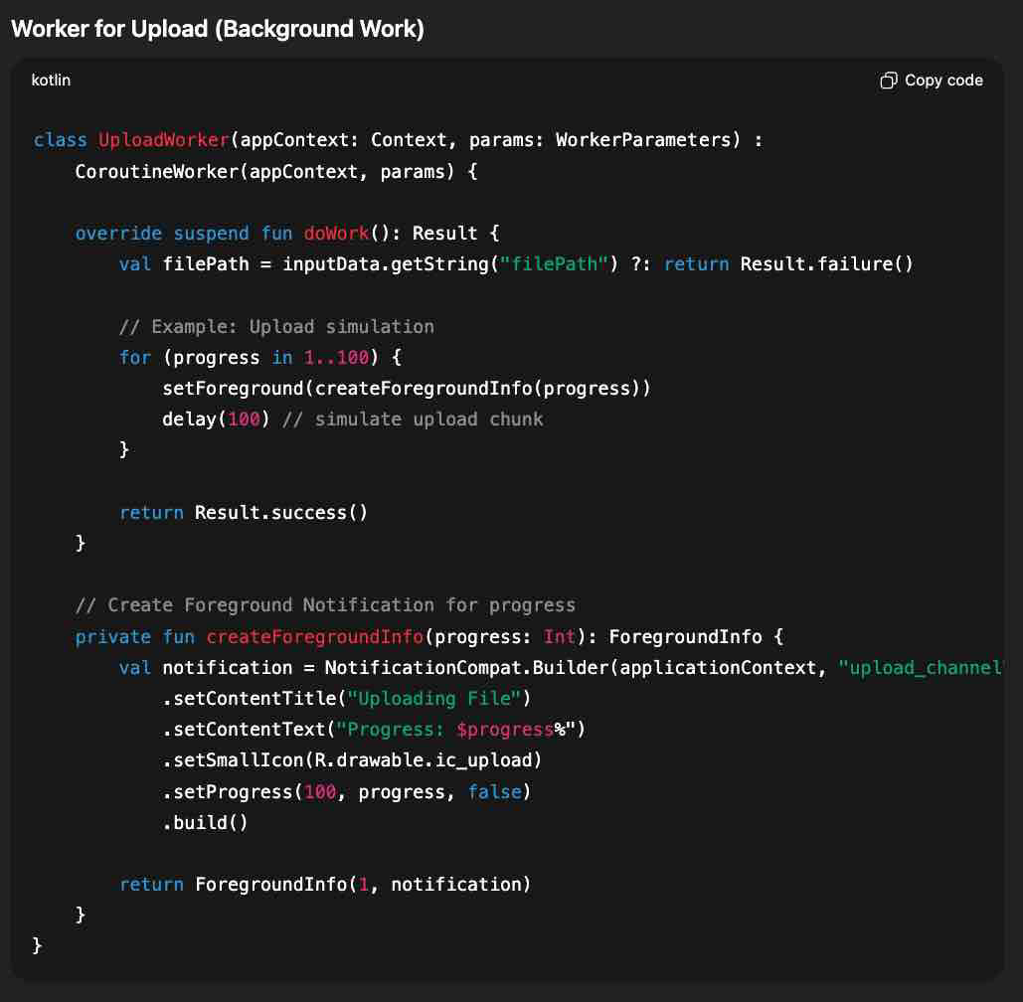

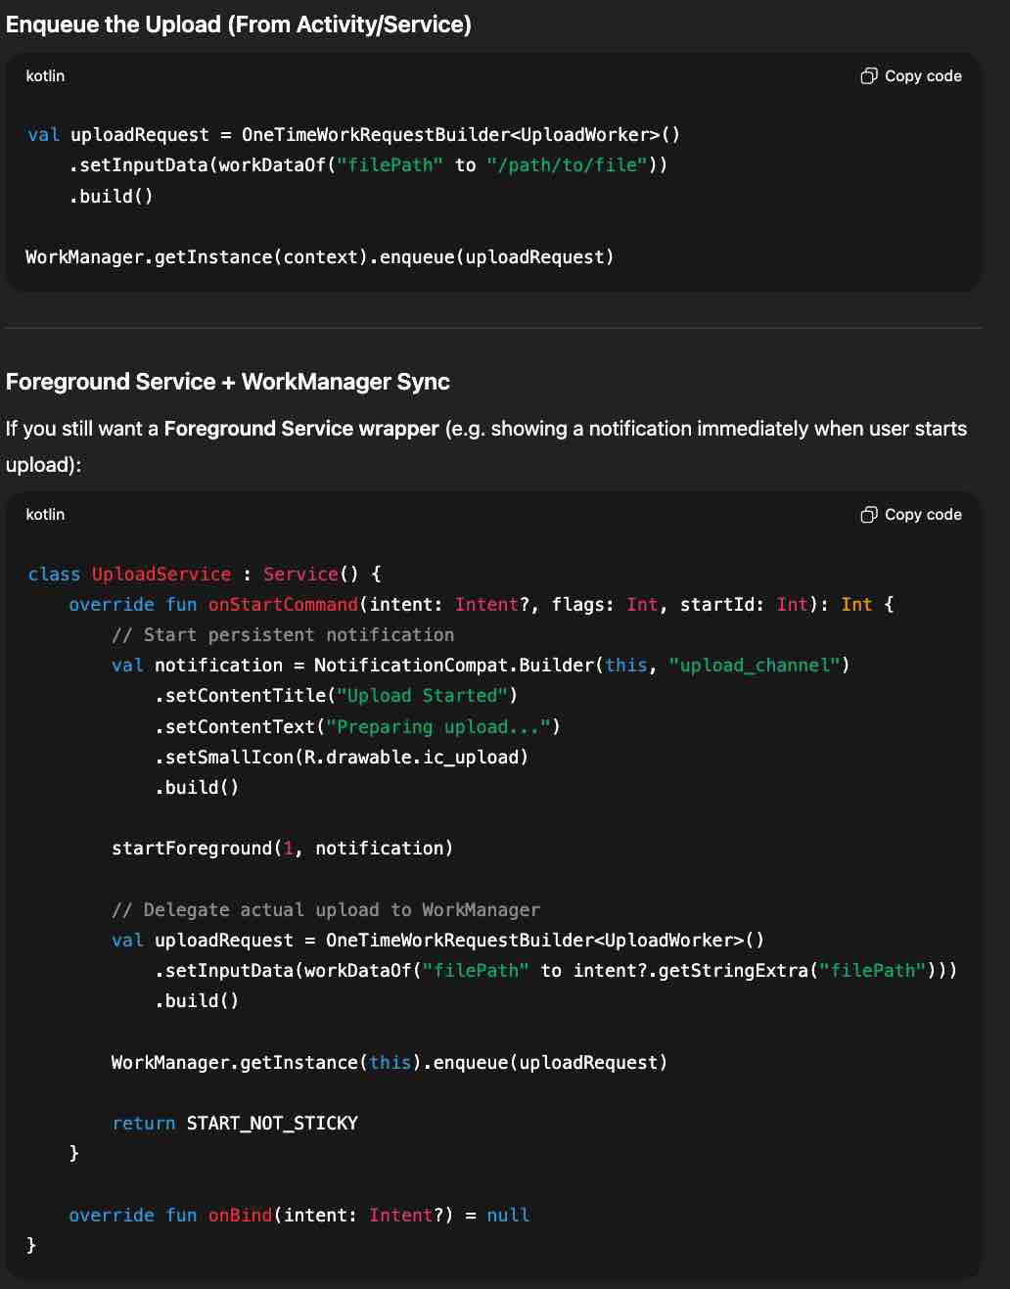

**Broadcast Receiver**